Whose Side in the Housing Wars Would Jane Jacobs Take Up Today?
The renowned urbanist allegedly wrote a protest song against Robert Moses with Bob Dylan. She might not sing the same tune about preservation today.
- Kriston Capps
- @kristoncapps
- May 4, 2016
- 6 Comments
- 139 Shares
- Share on Facebook
- Tweet

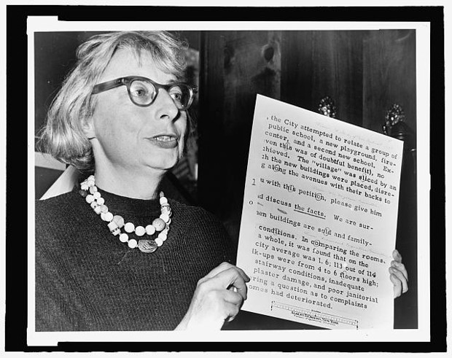Library of Congress
Of all the ways to celebrate a centenary, announcing a collab with Bob Dylan might be the tops. Days before Wednesday’s Google Doodle marked the 100th anniversary of Jane Jacobs’s birthday, her son confirmed with The Globe and Mail that mom co-wrote a song with Dylan to protest Robert Moses’ plans for Lower Manhattan. But of course she did.
No planner is so revered—well, that’s a silly thing to say, since no other urbanist comes close to boasting the household-name status that Jacobs enjoys. Her battles with Moses in New York over urban renewal, and her advocacy for a city scaled to the person on the street, made her famous. They earned her not just acclaim but a philosopher’s eminence in the public sphere.
In her son’s telling, Jacobs even taught Dylan how to write a protest song. Now, that’s so unlikely as to throw a shadow over the whole story. But the lyrics, if they are Dylan’s, read like something Jacobs would be saying in 1963:
Listen, Robert Moses, listen if you can
It’s all about our neighborhood that you’re trying to condemn
We aren’t going to sit back and see our homes torn down
So take your superhighway and keep it out of town
Part of her critical appreciation surely stems from the fact that she was right about a great many things, while her sparring partner, Moses, was so wrong. Urban renewal cut devastating racial and economic fault lines through cities. Had Moses (and others) succeeded in building the Lower Manhattan Expressway, some of the most beloved neighborhoods in New York would not exist today.
Still, it is hard to share wholeheartedly the sentiment, expressed by colleagues at this publication and others, that Jacobs’s lessons should still guide us today. Or maybe it is tempting to do so but hard to justify, looking at the challenges that stand ahead. “If Jane Jacobs were with us today, she would have every right to say: I told you so,” writes Roberta Brandes Gratz. That’s no doubt right.
But I wonder instead: If Jane Jacobs were with us today, would she still be singing the same tune?
In a 1963 letter to the chair of New York’s Landmarks Commission, Jacobs argues for expanding the area of Greenwich Village being considered for historic districting. The city had not included the West Village; this was absolutely necessary, Jacobs writes. She lists 177 Christopher, the site of one “Oelhaf’s marine works,” as one of the sites necessary for preserving the integrity and history of the West Village as an old river-landing settlement. Oelhaf’s shop includes a great pipe organ, she writes, a “marvel to behold and word of its quality has gone out on the sea lanes of the world so that an international roster of organists lists here and plays the instrument.”
That silly detail notwithstanding, Jacobs’s letter marshals an abundance of historical evidence and architectural knowledge to assert the significance of the neighborhood. “Visually, too the Village waterfront shows unique evidences of its unbroken historic continuity—and, again, not as ghostly lore or nostalgic pretense, but as part and parcel of the living reality,” Jacobs writes.
Today, Greenwich Village looks much like the one Jacobs fought for as far back as 1963. But it is nevertheless a transformed place. The median rent is $3,950 per month, while the median home sale price is $2.1 million, according to Trulia. Back in 1963, Jacobs fought to preserve the Village from being bulldozed for Moses’ highway. She succeeded. The ramifications of that victory are widely felt today.
In 2006, more than 40 years after Jacobs fought for and succeeded in attaining historic preservation status for Greenwich Village in 1969, the Greenwich Village Society for Historic Preservation succeeded in downzoning the West Village. “Today’s historic vote came just a few days after the death of Jane Jacobs and a few days before what would have been her 90th birthday on May 4th,” read a press release at the time.
In this regard, Jacobs’s work remains undone: Preservationists succeeded in extending the borders of the historic district in the Far West Village and East Village in 2010. Preservationists fought hard to keep New York Mayor Bill de Blasio from bringing market-rate housing to these neighborhoods as part of his citywide rezoning plan, which passed in March. They succeeded.
While the work of downzoning is being conducted in Jacobs’ neighborhood, in Jacobs’s name, Jacobs herself was more open to flexibility when it came to development. Consider her work in Toronto. The “Two Kings” regeneration plan for two post-industrial sites along the downtown waterfront—a plan authored by Jacobs (with others) and executed in 1996—has turned around the King-Spadina and King-Parliament districts. Jacobs’ own plan for redevelopment emphasized a flexible approach to land use.
“The results have been breathtaking—and might surprise those for whom Jane is a hero for stopping bulldozers,” writes urban planner Payton Chung. “Not only have the ‘Two Kings’ not lost jobs, as many industrial lands taken out of production have, but the number of jobs has increased by 58 percent. Even more impressively, 46,000 dwelling units have been permitted in the Two Kings, many of them in very large new high-rises.”
So it’s not entirely clear that Jacobs would approve of what’s happened with the West Village even in the few years since her death. Her final book, Dark Age Ahead, raised all the right alarms about income inequality and the threat that it poses to cities. Today, Jacobs’ ideas about preserving the character of the neighborhood in the face of Moses’ highway are raised as standards by people who want to preserve the character of their neighborhoods from any change at all. In a very real sense, saving the Village means destroying it.

